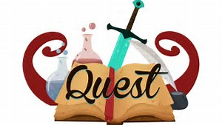
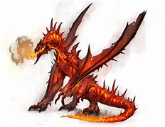
Year 6 Homework Grid – Adventure Quests!
English Tasks | Topic Tasks
Describe a villain or hero for a quest story. Think about their appearance, skill set, clothing, personality and any special powers or unique features they have. | Using your fantastic imagination, create a quest setting you might find in an adventure story. This could be presented as a painting, collage or in 3D form using junk modelling.
Write a film review of a quest film you’ve seen. For example, Star Wars, Jumanji, Harry Potter, Indiana Jones, The Hunger Games, The Hobbit or Zuthura. | Design a quest-like board game complete with instructions of how to play. Bring it in to show and play with your friends in class.
Maths Homework
Each week the children will bring home a piece of maths homework which will be based on the learning they would have done throughout the week. It should take between 30 and 60 minutes to complete it and will give us a chance to see their understanding outside the classroom environment. Please encourage them to have a go independently first and then feel free to help them afterwards or check through their answers. Thank you for your support.

Grammar Homework
Each week the children will bring home a piece of grammar homework to complete. This will help strengthen their writing and is also in preparation for the SATs tests they will be taking in May. Alongside this homework please encourage them to read regularly which will refine their understanding of everyday grammar, punctuation and spelling.

Reading Homework
Please encourage your child to read for a minimum of 20 minutes a night.
This will really support their writing, grammar and comprehension skills.

