Year 2: Paws, claws, wings and stings
Please complete at least 1 piece of homework from each section:
English | Maths | Topic
It’s a bug’s life!  Can you choose a living creature of your choice; it could be an animal or a bug. Research about your creature and create a Fact File.  As this is a non-fiction piece of writing you will need to think about:  What will your title be?  What will your subheadings be?  What pictures will you draw?  What facts can you write?  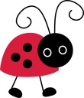  You can present your Fact File any way you like. | Let’s go on an adventure!  Can you explore the outdoors?  What bugs can you find?  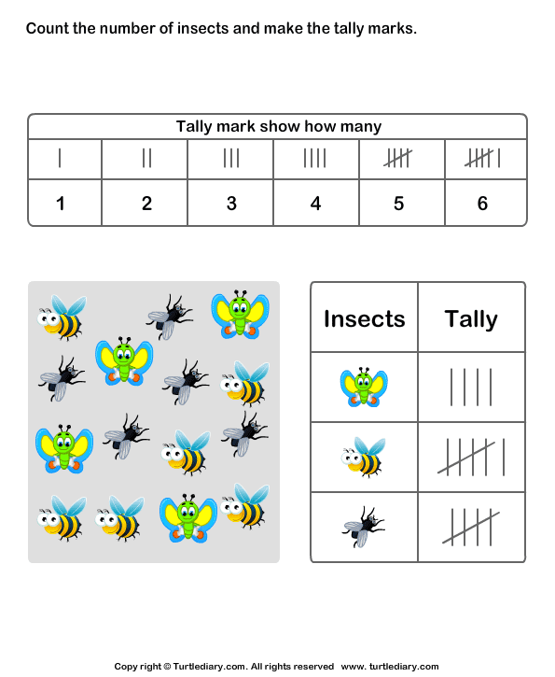  Can you record how many bugs you find and display this data in a Tally chart? What is the total number of each bug found? | 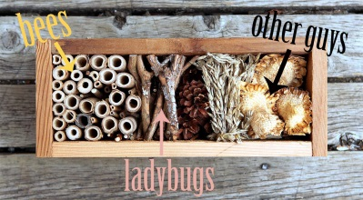  Welcome to the Bug Hotel!  Can you create your very own bug hotel using things you have found outside?  Choose a type of bug that your hotel will be welcoming. You must think about what materials your chosen bug would need to keep warm, sheltered and safe.  What conditions do they like to live in? What materials will you find for your hotel?
Books, books and more books!  Read a wide variety of both fiction and non- fiction books about bugs. What is the title? What is the book about? Is it fact or fictional? What have you learnt from the non- fiction books? Can you write a review about your favourite bug book?  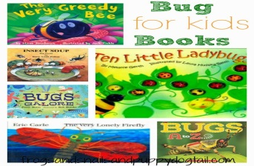 | How tall are they?  Use a ruler to measure some plants and stems of flowers. Record your measurements using cm and m.  . 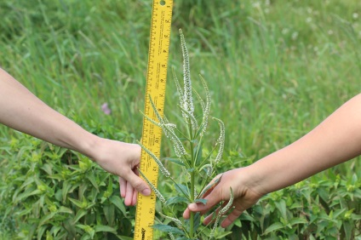 | 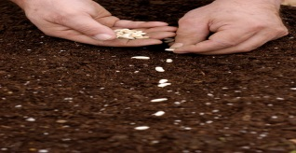  Let’s plant!  Plant a seed of your choice. You must find out about the conditions it needs to be in to grow well. Where should you keep it? How should you look after your planted seed? Over time, what do you notice? Are there any changes to your seed? Take a photo of you planting your seed to show us!
Growing plants  How do plants grow? What do the need to keep healthy? How should you look after a plant? Write a set of instructions for how to look after plants. You may need to do some research to help you! | Practise makes perfect!  Continue to practise your 2s, 3s, 5s and 10 times tables. Can you use division to show the inverse of these times tables?  ( 3 x 5 = 15, 15 5 = 3) | Let’s get imaginative!  Design and create your very own imaginative creature. What does it look like? Can it fly? How many legs does it have? Is it nocturnal? What does it eat? You can use junk modelling to make your creature.

These are starting suggestions of what could be done for homework. Please feel free to extend your child’s learning by completing other activities that are at your child’s ability level. Please feel free to add your homework tasks on Tapestry or bring them in as and when you have completed them.

These websites are great to help you with your child’s home learning.
https://www.topmarks.co.uk/

http://www.letters-and-sounds.com/

http://www.bbc.co.uk/schools/scienceclips/index_flash.shtml

http://www.primaryresources.co.uk/ Plenty of worksheets and PowerPoint presentations covering most of the core areas of the curriculum.

http://www.bbc.co.uk/schools/ Age appropriate, subject specific activities, games, worksheets and experiments. Also has revision activities.

