Literacy  As readers and writers we will enjoy exploring non-fiction books about different countries and healthy eating, atlases, and maps. We will continue to learn our phonics and put them into practice. |  |  |  | EAD  We will use different foods to create art work.  We will learn about songs and traditional dress from different countries.  We will continue to have 3 different role play areas in our classrooms. |  | Characteristics of Effective Learning  - Finding out and exploring  - Making links  - Enjoying achieving what they set out to do
Maths  As mathematicians we will be developing our understanding of number counting and recognition and ordering items by length, weight and capacity. We will be using different foods and ingredients in cooking to do this. |  |  |  |  |  | PD  We will practise using knives and forks to cut and eat our food and even have a go with chopsticks!
UW  We will be researching different countries and looking at people and communities which are different to ours.  We will look at traditional dishes and cuisines from around the world and discuss healthy foods and lifestyles.  We will talk about the things we have observed.  We will talk about e-safety on the computer. | PSED:  We will look at similarities and differences between ourselves and other races and religions. We will join with festivals and celebrations such as Easter and Chinese New Year.  We will continue learning about the Golden Rules at Underhill. | Trips and Visits:  Visit restaurants in the local area.  Parent visits for our new ‘Foody Thursday’ sessions.  Buy ingredients from the World Food Aisle of supermarkets. |  |  | 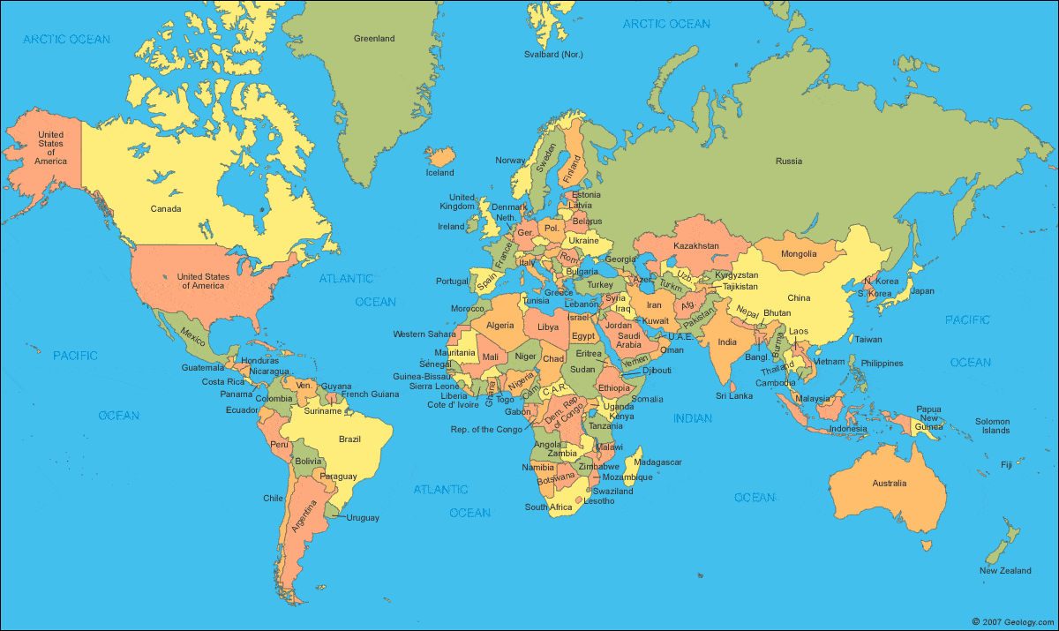
 | CL  We will be learning words and phrases in new languages including Makaton.  We will begin to ask questions and respond to others’ ideas.  We will practise listening well. |  | Reminders:  Parent Story Time - Monday 8.55am  New homework challenges sent out  Guided reading and library continues  Foody Thursdays begins  Swimming and Forest Schools continues |  |  | Grand Finale:  We hope to finish our topic with a trip to a local restaurant for lunch!

