Year 4 I will survive!
Literacy | Maths | Topic
Choose 3 animals from 3 different habitats. Find out at least 5 facts about each animal, their habitat and how they have adapted to the habitat. | Practice your times tables.  Super challenge!  Make an animal themed board game to play in class using times tables questions | Design and make a small habitat of your choice. You could use a shoe box and create your habitat inside. (If you didn’t do it over Easter)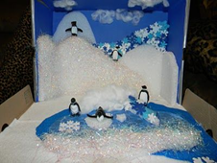
Write a detailed description of your favourite wild animal’s habitat.  Include colourful pictures. | Find out about 10 different endangered animals. How many are left in the wild?  Can you put it into a bar chart to go on our Habitats wall? | Design and make some food in the theme of animals. E.G: catapillar fruit kebab, animal biscuits, rolls, sandwiches.  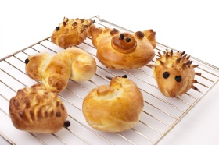bring them in to show the class.
Read some animal poems. Copy out your favourite in your neatest writing to share with the class. (Include the author’s name) | Make a shape picture of an animal in its habitat. Use regular shapes and make sure to label them using a key  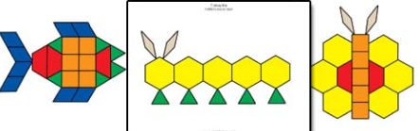 | Observe some animals in your garden/local park. Take some pictures or draw pictures of the animals and bring them in.
Here are some ideas for you and your child to do at home. Please choose and complete at least 4 from the activities below (at least 1 from each subject). Please bring them in as and when you complete them. In the last week of half term the children will share and celebrate their fantastic work with each other.

