Underhill School and Children’s Centre

Recommended Reading List

Year 5
If your child is a competent reader or has read all these titles then try the books from the Year 6 list. Alternatively if these books are a little challenging try books from the Year 4 list.
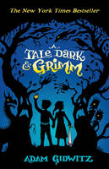 |  | A Tale Dark and Grimm  Adam Gidwitz  Reader: beware. Warlocks with dark spells, hunters with deadly aim, and bakers with ovens retrofitted for cooking children lurk within these pages. But if you dare, turn the page and learn the true story of Hansel and Gretel - the story behind (and beyond) the bread crumbs, edible houses and outwitted witches. Come on in. It may be frightening, it's certainly bloody, and it's definitely not for the faint of heart

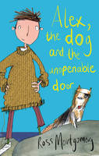 |  | Alex, the Dog and the Unopenable Door  Ross Montgomery  Alex Jennings is a boy with a problem. His mum's sent him away to boarding school because his father, the most famously failed explorer in the history of the Cusp, has escaped from hospital again, yelling 'squiggles'. Make that two problems. Now the evil Davidus Kyte and all his henchmen are after Alex, convinced he alone knows the meaning of the word 'squiggles'. OK, make that three - Alex Jennings is a boy with a lot of problems. But with the help of a talking dog and a girl with unfeasibly sharp teeth, he just might have what it takes to cross the Forbidden Lands, escape the evil Davidus Kyte, and find out what lies beyond the Cusp ...

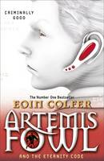 |  | Artemis Fowl and the Eternity Code  Eoin Colfer  Thirteen-year-old criminal mastermind Artemis Fowl has constructed a supercomputer from stolen fairy technology. In the wrong hands it could be fatal for humans and fairies alike. But no need to worry, Artemis has a brilliant plan. He's not going to use the computer; he's just going to show it to a ruthless American businessman with Mafia connections. His bodyguard, Butler, will be with him. What could possibly go wrong...?

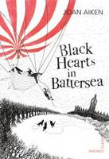 |  | Black Hearts in Battersea  Joan Aiken  'Wait, wait! Save us! What'll we do?' Simon is determined to become a painter when he grows up so he sets off to London to make his fortune. But the city is plagued by wolves and mysterious disappearances. The Twite household, where Simon is lodging, seems particularly shifty. Before he even gets a chance to open his glistening new paints Simon stumbles right into the centre of a plot to kill the King. And worse than that Simon is kidnapped and sent to sea! Luckily there are two friendly stowaways aboard - the feisty Dido Twite and the spoiled young Justin. But when the ship catches fire things look pretty dire. Can they escape? Will they save the king in time?

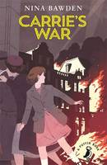 |  | Carrie's War  Nina Bawden, Julia Eccleshare  Carrie's War by Nina Bawden is an unforgettable Second World War story. 'I did a dreadful thing ...or I feel that I did, and nothing can change it...' It is the Second World War and Carrie and Nick are evacuated from London to a small town in Wales, where they are placed with strict Mr Evans and his timid mouse of a sister. Their friend Albert is luckier, living in Druid's Bottom with Hepzibah Green who tells wonderful stories, and the strange Mister Johnny, who speaks a language all of his own. Carrie and Nick are happy to visit Albert there, until one day when Carrie does a terrible thing - the worst thing she ever did in her life.

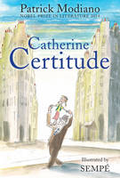 |  | Catherine Certitude  Patrick Modiano  This is a classic French story from Nobel Prize-winner Patrick Modiano and celebrated illustrator Jean-Jacques Sempe. Beautifully illustrated, this is a love letter to Paris, ballet and childhood for fans of The Little Prince, Le Petit Nicholas and Madeline. Catherine lives with her gentle father, Georges Certitude, who runs a shipping business in Paris with a failed poet named Casterade. Father and daughter share the simple pleasures of daily life: sitting in the church square, walking to school, going to her ballet class every Thursday afternoon. But just why did Georges change his name to Certitude? What kind of trouble with the law did Casterade rescue him from? And why did Catherine's ballerina mother leave to return to New York?

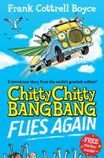 |  | Chitty Chitty Bang Bang 1: Flies Again  Frank Cottrell Boyce  When the Tooting family find a vast abandoned engine and fit it to their camper van, they have no idea of the adventure that lies ahead. The engine used to belong to an extraordinary flying car - and it wants to be back on the road again ...fast! The Tootings can haul on the steering wheel and pull the handbrake as hard as they like, but their camper van now has a mind of her own. It's not long before they're hurtling along on a turbocharged chase as Chitty tracks down her long-lost bodywork. But there are sinister forces at work too. When it comes to a car as special as Chitty, everybody wants a piece of her ...

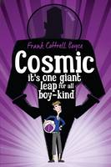 |  | Cosmic  Frank Cottrell Boyce  It's one giant leap for all boy-kind in Frank Cottrell Boyce's out-of-this-world story: Cosmic. Liam is too big for his boots. And his football strip. And his school blazer. But being super-sized height-wise has its advantages: he's the only eleven-year-old to ever ride the G-force-defying Cosmic rollercoaster - or to be offered the chance to drive a Porsche. Long-legged Liam makes a giant leap for boy-kind by competing with a group of adults for the chance to go into space. Is Liam the best boy for the job? Sometimes being big isn't all about being a grown-up.

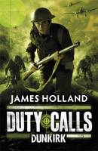 |  | Duty Calls: Dunkirk  James Holland  Duty Calls: Dunkirk by James Holland is a gripping true-to-life story about one of the most dramatic events of World War II. 'You wanted to see some action - well you're going to get it now. You're going to get it now all right'. Friday 24th May, 1940 Private Johnny Hawke, aged sixteen, awakens to artillery fire. Hours later, Stukas scream down from the sky. Messerschmit fighters roar towards his regiment. Trucks burst into flames. Now men and mules lay dead and dying, severed limbs twisted grotesquely as blood soaks the cobbled streets. Young Private Hawke just wants to do his duty and serve his country. But as he - and his fellow soldiers - prepare to stop the German advance, there's only one question on everyone's lips. How will they survive?

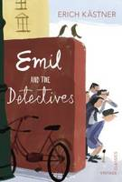 |  | Emil and the Detectives  Erich Kastner  'Password Emil!' Emil is excited to be taking the train on his own for the first time. He doesn't like the look of his fellow passenger, the man in the bowler hat. Emil will just have to keep his wits about him and his money in his pocket. But Emil falls asleep and when he wakes up the man in the bowler hat is gone - and so is the money! Emil is determined to get it back. He teams up with a gang of young detectives and so begins a hair-raising chase across Berlin to catch the dirty rotten thief...

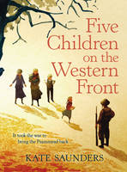 |  | Five Children on the Western Front Inspired by E. Nesbit's Five Children and it Stories  Kate Saunders  This is an epic, heart-wrenching follow-on from E. Nesbit's Five Children and It stories. The five children have grown up and World War I has begun in earnest. Cyril is off to fight, Anthea is at art college, Robert is a Cambridge scholar and Jane is at high school. The Lamb is the grown up age of 11, and he has a little sister, Edith, in tow. The sand fairy has become a creature of stories ...until, for the first time in 10 years, he suddenly reappears. The siblings are pleased to have something to take their minds off the war, but this time the Psammead is here for a reason, and his magic might have a more serious purpose. Before this last adventure ends, all will be changed, and the two younger children will have seen the Great War from every possible viewpoint - factory-workers, soldiers, nurses and ambulance drivers, and the people left at home, and the war's impact will be felt right at the heart of their family.

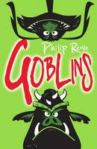 |  | Goblins  Philip Reeve  A wild world of magical creatures and heroic adventure from the extraordinary imagination of Philip Reeve. The squabbling goblins who live in the great towers of Clovenstone spend their time fighting and looting. Only clever young Skarper understands that dark magic created by a vanquished sorcerer is rising again. From the lands of men come fortune-seekers - and trolls, giants, cloud-maidens, boglins, swamp monsters, tree-warriors and bloodthirsty goblins are swept into a fabulous magical conflict to thrill all fantasy fans.

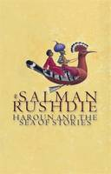 |  | Haroun and the Sea of Stories  Salman Rushdie  Haroun's father is the greatest of all storytellers. His magical stories bring laughter to the sad city of Alifbay. But one day something goes wrong and his father runs out of stories to tell. Haroun is determined to return the storyteller's gift to his father. So he flies off on the back of the Hoopie bird to the Sea of Stories - and a fantastic adventure begins.

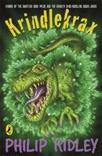 |  | Krindlekrax  Philip Ridley  Ruskin Splinter is small and thin, with knock-knees, thick glasses and a squeaky voice, and the idea of him taming a dragon makes the whole class laugh. Big, strong Elvis is stupid but he looks like a hero. So who is more likely to get the big part in the school play? But when the mysterious beast, Krindlekrax, threatens Lizard Street and everyone who lives there, it is Ruskin who saves the day and proves he is the stuff that heros are made of after all.

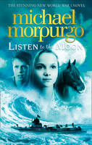 |  | Listen to the Moon  Michael, M. B. E. Morpurgo  The stunning novel set during World War One from Michael Morpurgo, the nation's favourite storyteller and multi-million copy bestseller. May, 1915. Alfie and his fisherman father find a girl on an uninhabited island in the Scillies - injured, thirsty, lost...and with absolutely no memory of who she is, or how she came to be there. She can say only one word: Lucy. Where has she come from? Is she a mermaid, the victim of a German U-boat, or even - as some islanders suggest - a German spy...? Only one thing is for sure: she loves music and moonlight, and it is when she listens to the gramophone that the glimmers of the girl she once was begin to appear. WW1 is raging, suspicion and fear are growing, and Alfie and Lucy are ever more under threat. But as we begin to see the story of Merry, a girl boarding a great ship for a perilous journey across the ocean, another melody enters the great symphony - and the music begins to resolve...A beautiful tour de force of family, love, war and forgiveness, this is a major new novel from the author of PRIVATE PEACEFUL - in which what was once lost may sometimes be found, washed up again on the shore...

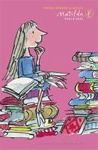 |  | Matilda  Roald Dahl, Julia Eccleshare  Matilda is a brilliant and sensitive child, but her parents think of her only as a nuisance. Even before she is five years old, she has read Dickens and Hemingway and still her parents think of her as a pest. So she decides to get back at them. Her platinum-haired mother and car salesman father are no match for her sharp genius, and neither is the cruel headmistress Miss Trunchbull. And then the child prodigy discovers she has an extraordinary magic power that can save her school and especially the lovely kindergarten teacher, Miss Honey.

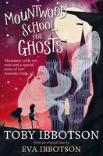 |  | Mountwood School for Ghosts  Toby Ibbotson  Fredegonda, Goneril, and Drusilla are Great Hagges, much more important and much rarer than regular old hags. They think that ghosts these days are decidedly lacking and that people haven't been scared of ghosts for years. So one day they decide that something needs to change - it's time for these ghosts to learn a thing or two about being scary. And what better way to teach them than to set up their very own school for ghosts?

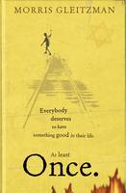 |  | Once  Morris Gleitzman  Once by Morris Gleitzman is the story of a young Jewish boy who is determined to escape the orphanage he lives in to save his Jewish parents from the Nazis in the occupied Poland of the Second World War. Everybody deserves to have something good in their life. At least Once. Once I escaped from an orphanage to find Mum and Dad. Once I saved a girl called Zelda from a burning house. Once I made a Nazi with a toothache laugh. My name is Felix. This is my story. Once is the first in a series of children's novels about Felix, a Jewish orphan caught in the middle of the Holocaust, from Australian author Morris Gleitzman - author of Bumface and Boy Overboard. The next books in the series Then, Now and After are also available from Puffin.

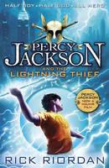 |  | Percy Jackson and the Lightning Thief  Rick Riordan  Half boy. Half God. All Hero. Look, I didn't want to be a half-blood. I never asked to be the son of a Greek God. I was just a normal kid, going to school, playing basketball, skateboarding. The usual. Until I accidentally vaporized my maths teacher. Now I spend my time battling monsters and generally trying to stay alive. This is the one where Zeus, God of the Sky, thinks I've stolen his lightning bolt - and making Zeus angry is a very bad idea.

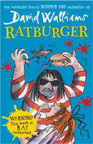 |  | Ratburger  David Walliams  The fifth screamingly funny novel from David Walliams, number one bestseller and fastest growing children's author in the country, now available in paperback. From the bestselling author of Gangsta Granny and Demon Dentist comes another hilarious, action-packed and touching novel - the story of a little girl called Zoe. Things are not looking good for Zoe. Her stepmother Sheila is so lazy she gets Zoe to pick her nose for her. The school bully Tina Trotts makes her life a misery - mainly by flobbing on her head. And now the evil Burt from Burt's Burgers is after her pet rat! And guess what he wants to do with it? The clue is in the title...From the author that is being called 'a new Roald Dahl', Ratburger is not to be missed!

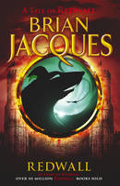 |  | Redwall  Brian Jacques  Redwall Abbey, tranquil home to a community of peace-loving mice is threatened by Cluny the Scourge - the evil-one-eyed rat warlord - and his battle-hardened horde of predators. Cluny is certain that Redwall will fall easily to his fearsome army but he hasn't bargained for the courage and strength of the combined forces of the Redwall mice and their loyal woodland friends...

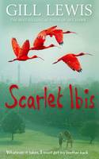 |  | Scarlet Ibis  Gill Lewis  Longlisted for the 2015 Carnegie Medal.Red asks, 'Will we always be together?' 'Always,' I say. 'Just you and me in that little boat, watching the scarlet ibis flying back to the Caroni Swamp.' Scarlet's used to looking after her brother, Red. He's special - different. Every night she tells him his favourite story - about the day they'll fly far away to the Caroni Swamp in Trinidad, where thousands of birds fill the sky. But when Scarlet and Red are split up and sent to live with different foster families, Scarlet knows she's got to do whatever it takes to get her brother back ...A wonderfully moving new novel from the author of Sky Hawk and White Dolphin.

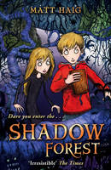 |  | Shadow Forest  Matt Haig  Samuel Blink is the hero of this story, but he doesn't know it yet. Right now, he and his sister Martha are in the back of his parents' car. He has no idea a giant log is about to fall from the sky and change his life forever. He doesn't know that he and Martha will be forced to move to Norway and eat their Aunt Eda's smelly brown cheese. He hasn't the slightest clue Martha will disappear into Shadow Forest. A forest full of one-eyed trolls, the sinister huldre-folk, deadly Truth Pixies and a witch who steals shadows. A forest ruled by the evil Changemaker. A forest so dangerous that people who enter never return. No. Samuel Blink doesn't know any of this. So don't tell him. It might ruin the book ...Winner of the Gold Smarties Prize and the Blue Peter Award, and shortlisted for the Carnegie Medal and the Waterstone's Prize.

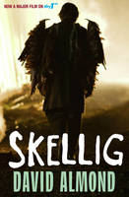 |  | Skellig  David Almond  When a move to a new house coincides with his baby sister's illness, Michael's world seems suddenly lonely and uncertain. Then, one Sunday afternoon, he stumbles into the old, ramshackle garage of his new home, and finds something magical. A strange creature - part owl, part angel, a being who needs Michael's help if he is to survive. With his new friend Mina, Michael nourishes Skellig back to health, while his baby sister languishes in the hospital. But Skellig is far more than he at first appears, and as he helps Michael breathe life into his tiny sister, Michael's world changes forever ...Skellig won the Carnegie Medal and the Whitbread Children's Book Award and is now a major Sky1 feature film, starring Tim Roth and John Simm. David Almond is also winner of the 2010 Hans Christian Andersen award.

Stormbreaker
Anthony Horowitz
When his guardian dies in suspicious circumstances, fourteen-year-old Alex Rider finds his world turned upside down. Forcibly recruited into MI6, Alex has to take part in gruelling SAS training exercises. Then, armed with his own special set of secret gadgets, he's off on his first mission to Cornwall, where Middle-Eastern multi-billionaire Herod Sayle is producing his state-of-the-art Stormbreaker computers. Sayle has offered to give one free to every school in the country - but there's more to the gift than meets the eye.

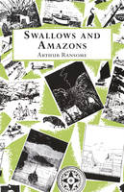 |  | Swallows and Amazons  Arthur Ransome  The ultimate children's classic - long summer days filled with adventure. John, Susan, Titty and Roger sail their boat, Swallow, to a deserted island for a summer camping trip. Exploring and playing sailors is an adventure in itself but the island holds more excitement in store. Two fierce Amazon pirates, Nancy and Peggy, challenge them to war and a summer of battles and alliances ensues. 'My childhood simply would not have been the same without this book. It created a whole world to explore, one that lasted long in the imagination after the final page had been read' - Marcus Sedgwick

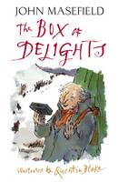 |  | The Box of Delights  John Masefield  'Two of the greatest children's books ever written' - The Times on Box of Delights and The Midnight Folk. 'And now, Master Harker, now that the Wolves are Running, perhaps you could do something to stop their Bite?' A magical old man has asked Kay to protect the Box of Delights, a Box with which he can travel through time. But Kay is in danger: Abner Brown will stop at nothing to get his hands on it. The police don't believe Kay, so when his family and the Bishop are scrobbled up just before Christmas, he knows he must act alone ...John Masefield's classic children's book is considered to be one of the great works of modern children's fiction. Magical, fantastical and filled with vivid, rich characters - brought to life in this edition by Quentin Blake's stunning artwork - The Box of Delights and its sequel The Midnight Folk are a must-read for any child.

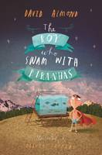 |  | The Boy Who Swam with Piranhas  David Almond  Stanley Potts is just an ordinary boy, but when all the jobs in Fish Quay disappear his Uncle Ernie develops an extraordinary fascination with canning fish. Suddenly their home is filled with the sound of clanging machinery and the stench of mackerel, and Uncle Ernie's obsession reaches such heights that he would even can Stan's beloved goldfish! Stan, however, has his own destiny, which leads him - via a hook-a-duck stall - to Pancho Pirelli, the blue-caped madman who swims with piranhas. And as Stan delves into the waters, he finally discovers who he really can be.

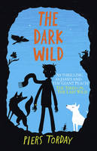 |  | The Dark Wild  Piers Torday  WINNER OF THE GUARDIAN CHILDREN'S FICTION PRIZE 2014. Twelve-year-old Kester thought he had discovered the last wild animals in the land. He thought his adventure was over. He was wrong. Below the sparkling city of Premium, deep underground, a dark wild remains: animals who believe the time is right to rise up against their human enemies. And soon Kester realises: he is the only one who can stop them. Kester Jaynes saved the animals. Can he save the humans too?

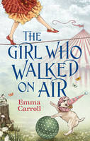 |  | The Girl Who Walked On Air  Emma Carroll  Louie, who was abandoned at Chipchase's Travelling Circus as a baby, dreams of becoming a 'Showstopper', but Mr Chipchase keeps her hidden, tucked away in the ticket booth. No Death-Defying Stunts for her. But Louie has been secretly practising her act - tightrope-walking - and dreams of being the Girl Who Walked on Air ...she just needs to be given the chance to shine. And the circus needs her too - Wellbeloved's rival show is stealing their crowds. They need a Showstopper. Desperate, Mr Chipchase reluctantly lets Louie perform. She is a sensation, and gets an offer from the sinister Mr Wellbeloved himself to perform ...over Niagara Falls. But nothing is quite as it seems and soon Louie's bravery is tested not just on the highwire but in confronting her past and the shady characters in the world of the circus ...Fans of Frost Hollow Hall will love this epic adventure about following your dreams and becoming a showstopper!

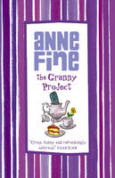 |  | The Granny Project  Anne Fine  What does he mean? What's going on? Are you two thinking of putting Granny into a Home? Thinking is finished,' Natasha told him. 'It is decided. The four children, Ivan, Sophie, Tanya and Nicholas, can't believe it. Their parents are planning to put their grandmother into a Home. She's a bit of a dotty old lady - sometimes demanding, often annoying - but as much a part of their lives as their shambly house or the whirring of the washing machine. So they decide to take action. They begin 'The Granny Project', with immediate and sensational results...

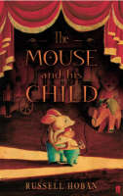 |  | The Mouse and His Child  Russell Hoban  'Brilliantly plotted ...a spellbinder ...it has a style that glows and crackles.' Spectator 'Hugely funny, provocative, pathetic and heroic.' TLS 'What are we, Papa?' the toy mouse child asked his father. 'I don't know,' the father answered. 'We must wait and see.' So begins the story of a tin father and son who dance under a Christmas tree until they break the ancient clockwork rules and are themselves broken. Thrown away, then rescued from a dustbin and repaired by a tramp, they set out on a dangerous quest for a family and a place of their own - the magnificent doll's house, the plush elephant and the tin seal they had once know in the toy shop.

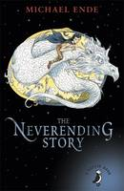 |  | The Neverending Story  Michael Ende  Small and insignificant Bastian Balthazar Bux is nobody's idea of a hero, least of all his own. Through the pages of an old book he discovers a mysterious world of enchantment - but a world that is falling into decay. The great task of making things well again falls on Bastian and so begins a dazzling, magical adventure.

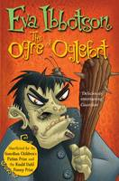 |  | The Ogre of Oglefort  Eva Ibbotson  When a Hag, an orphan boy called Ivo, Ulf the troll and wizard Brian Brainsweller are sent to rescue a princess from an ogre, they briefly consider running away and hiding. Can they be any match for the gruesome, terrifying, ghastly, flesh-eating Ogre of Oglefort? But not all is as it first appears - the Ogre is depressed and the princess doesn't want to be rescued. The Norns, who rule their fates, decide to take things in hand and send a gang of the vilest, most petrifying ghouls to get the job done properly...

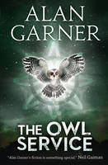 |  | The Owl Service  Alan Garner  Winner of both the Guardian Award and the Carnegie Medal, this is an all-time classic, combining mystery, adventure, history and a complex set of human relationships. It all begins with the scratching in the ceiling. From the moment Alison discovers the dinner service in the attic, with its curious pattern of floral owls, a chain of events is set in progress that is to effect everybody's lives. Relentlessly, Alison, her step-brother Roger and Welsh boy Gwyn are drawn into the replay of a tragic Welsh legend - a modern drama played out against a background of ancient jealousies. As the tension mounts, it becomes apparent that only by accepting and facing the situation can it be resolved.

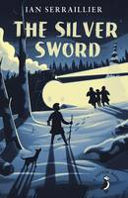 |  | The Silver Sword  Ian Serraillier  Although the silver sword was only a paper knife, it became the symbol of hope and courage which kept the Balicki children and their orphan friend Jan alive through the four years of occupation when they had to fend for themselves. And afterwards it inspired them to keep going on the exhausting and dangerous journey from war-torn Poland to Switzerland, where they hoped to find their parents. Based on true accounts, this is a moving story of life during and after the Second World War.

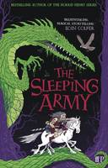 |  | The Sleeping Army  Francesca Simon  Freya is an ordinary girl living in modern Britain, but with a twist: people still worship the Viking gods. One evening, stuck with her dad on his night shift at the British Museum, she is drawn to the Lewis Chessmen and Heimdall's Horn. Unable to resist, she blows the horn, waking three chess pieces from their enchantment; the slaves Roskva and Alfi, and Snot the Berserk. They are all summoned to Asgard, land of the Viking gods, and told they must go on a perilous journey to restore the gods to youth. If Freya refuses she will be turned into an ivory chess piece but, if she accepts her destiny and fails, the same terrible fate awaits her.

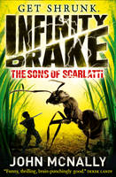 |  | The Sons of Scarlatti  John McNally  Get shrunk! Humour and high-stakes combine in the action-packed Infinity Drake series. A BIG adventure with a tiny hero...Infinity Drake and his scientist uncle are summoned to a crisis meeting. A power-mad villain has released a doomsday bio-weapon - the mutant Scarlatti wasp. Millions of lives are in danger, but Uncle Al has a crazy plan that just might work...Soon he's shrinking a crack military team to take down the wasps. But a double agent throws the mission and now Finn is 9mm tall and has the weight of the world's survival on his tiny shoulders. Killer bugs: It's time to pick on someone your own size!

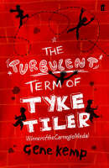 |  | The Turbulent Term of Tyke Tiler  Gene Kemp  Tyke Tiler is very fond of jokes, that's why there are so many in this story. Tyke is also fond of Danny Price, who is not too bright and depends a lot on his friend. Together Tyke and Danny are double trouble.

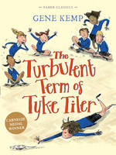 |  | The Turbulent Term of Tyke Tiler  Gene Kemp  The Turbulent Term of Tyke Tiler is considered one of the children's classics of the twentieth century, and contains one of the most amazing and affirming twists in all of literature. Tyke Tiler and Danny Price are best friends, much to the despair of the headmaster of Cricklepit Combined School - because wherever the pair go, trouble is never far behind. Stolen money, a sheep's skeleton, fights in class...And somehow it's always trouble that Tyke has to sort out. Can Tyke help the hapless Danny stay out of trouble for their last term? And what final surprise does Tyke have in store? Mischief and astonishment abound in this hilariously funny classic story from award-winning author Gene Kemp.

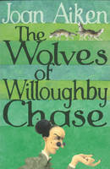 |  | The Wolves of Willoughby Chase  Joan Aiken  1832 - a period of English History that never happened. Good King James III is on the throne and the country is ravaged by wolves which have migrated through the newly-opened Channel Tunnel. When Sylvia and Bonnie (both orphans) fall into the hands of evil Miss Slighcarp, they must use all their wits to escape unscathed - for the governess is more cruel and merciless than the wolves that surround the great house of Willoughby Chase.

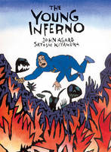 |  | The Young Inferno  John Agard  Can our hoodie hero make it through nine circles of Hell and back again? Will he find love with his soulmate, Beatrice? Discover the city of Dis where everybody disses everybody. Meet Frankenstein, the lovesick bouncer with the bling-bling. Come face to face with the Furies, a gang of snake-haired females in T-shirts. Prepare for a host of gluttons, bigots and plunderers from the world of history and politics. John Agard fires Dante's Inferno into the 21st century in a red-hot retelling, with wicked artwork from Satoshi Kitamura.

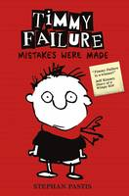 |  | Timmy Failure: Mistakes Were Made  Stephan Pastis  Perfect for fans of Wimpy Kid and Big Nate, Timmy Failure: Mistakes Were Made is the first book in the New York Times bestselling series. Listed as one of 100 Modern Children's Classics by The Sunday Times, it was also a Booktrust Best Book Awards winner. Meet Timmy Failure, founder of the best detective agency in town - Total Failure, Inc. With the help of his polar bear, Total, the clueless, comically self-confident Timmy already has plans for world domination. Plans that will make his mother rich and unpaid bills a thing of the past. And plans that will defeat Corrina Corrina, The One Whose Name Shall Not Be Uttered . But she's not going away. Riotously funny, Timmy Failure is sure to have readers in stitches.

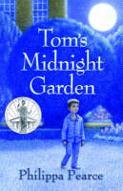 |  | Tom's Midnight Garden  Philippa Pearce  Lying awake at night, Tom hears the old grandfather clock downstairs strike ...eleven ...twelve ...thirteen ...Thirteen! When Tom gets up to investigate, he discovers a magical garden. A garden that everyone told him doesn't exist. A garden that only he can enter ...A Carnegie-Medal-winning modern classic that's magically timeless.

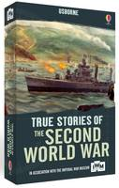 |  | True Stories of the Second World War  Henry Brook, Paul Dowswell  A boxed set of three paperback books from the True Stories series: The Blitz, D-Day and The Second World War. Each book contains a series of real-life accounts of bravery and heroism, as well as providing a realistic portrayal of the horrors of war. Published in association with the Imperial War Museums.

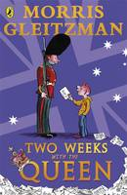 |  | Two Weeks with the Queen  Morris Gleitzman  'I need to see the Queen about my sick brother.' Colin Mudford is on a quest. His brother Luke has cancer and the doctors in Australia don't seem to be able to cure him. Sent to London to stay with relatives, Colin is desperate to do something to help Luke. He wants to find the best the doctor in the world. Where better to start than by going to the top? Colin is determined to ask the Queen for her advice. In Morris Gleitzman's trademark style, this very moving story illuminates deeply serious issues about illness and loss with bright moments of humour.

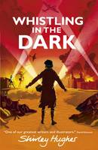 |  | Whistling in the Dark  Shirley Hughes  Liverpool, 1940: thirteen-year-old Joan's home is under threat from the Nazi's terrifying nightly air-raids. It is not an easy time to be a teenager, especially with the sweet rationing, strict curfews and blackouts. Joan and best friend Doreen love going to the cinema until the bombings intensify and then even that becomes too dangerous, especially when an army deserter is found lurking near their home. Who is he and why does he think Joan can help him? As the Blitz worsens, Joan and her friends make a discovery that will tear the whole community apart...

