Dear Parents/Carers,

After the October half term, we will be starting our new topic Hola Mexico.

We will learn about Mexican festivals, such as the Day of the Dead, and we will find out about the rich Mexican culture.

To get you ready for the topic here are some homework ideas to get you excited about the topic.

Go to your local library and find some book about the ancient Mayans.

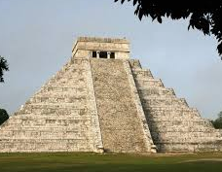

Can you write a fact file about Mayans?

Why don’t you prepare a Mexican meal?

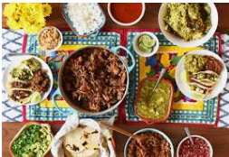

Can you write the recipe down?

Music is a big part of the Mexican culture. Why don’t you watch a video of a Mariachi band playing. What instruments can you hear?

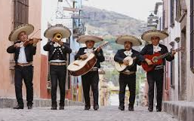

What instruments are they using?

